Maven Build Phases and Commands :

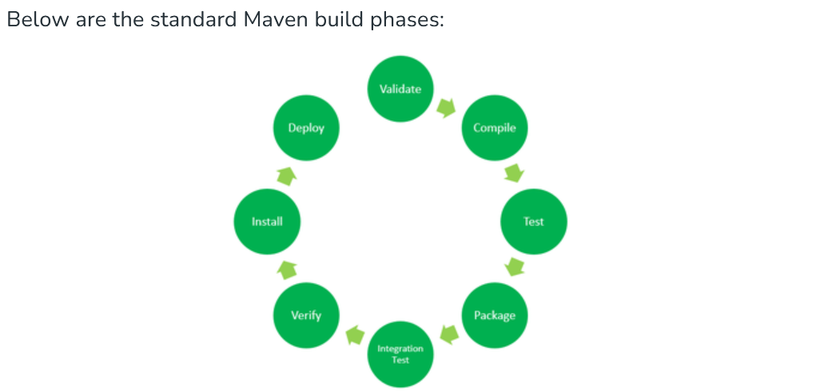

Command -1

mvn --clean

The **mvn clean** command in Maven is used to remove the target directory and all the build artifacts contained within it.

What is target directory in maven.

The target directory is **used to house all output of the build**. The src directory contains all of the source material for building the project, its site and so on. It contains a subdirectory for each type: main for the main build artifact, test for the unit test code and resources, site and so on.

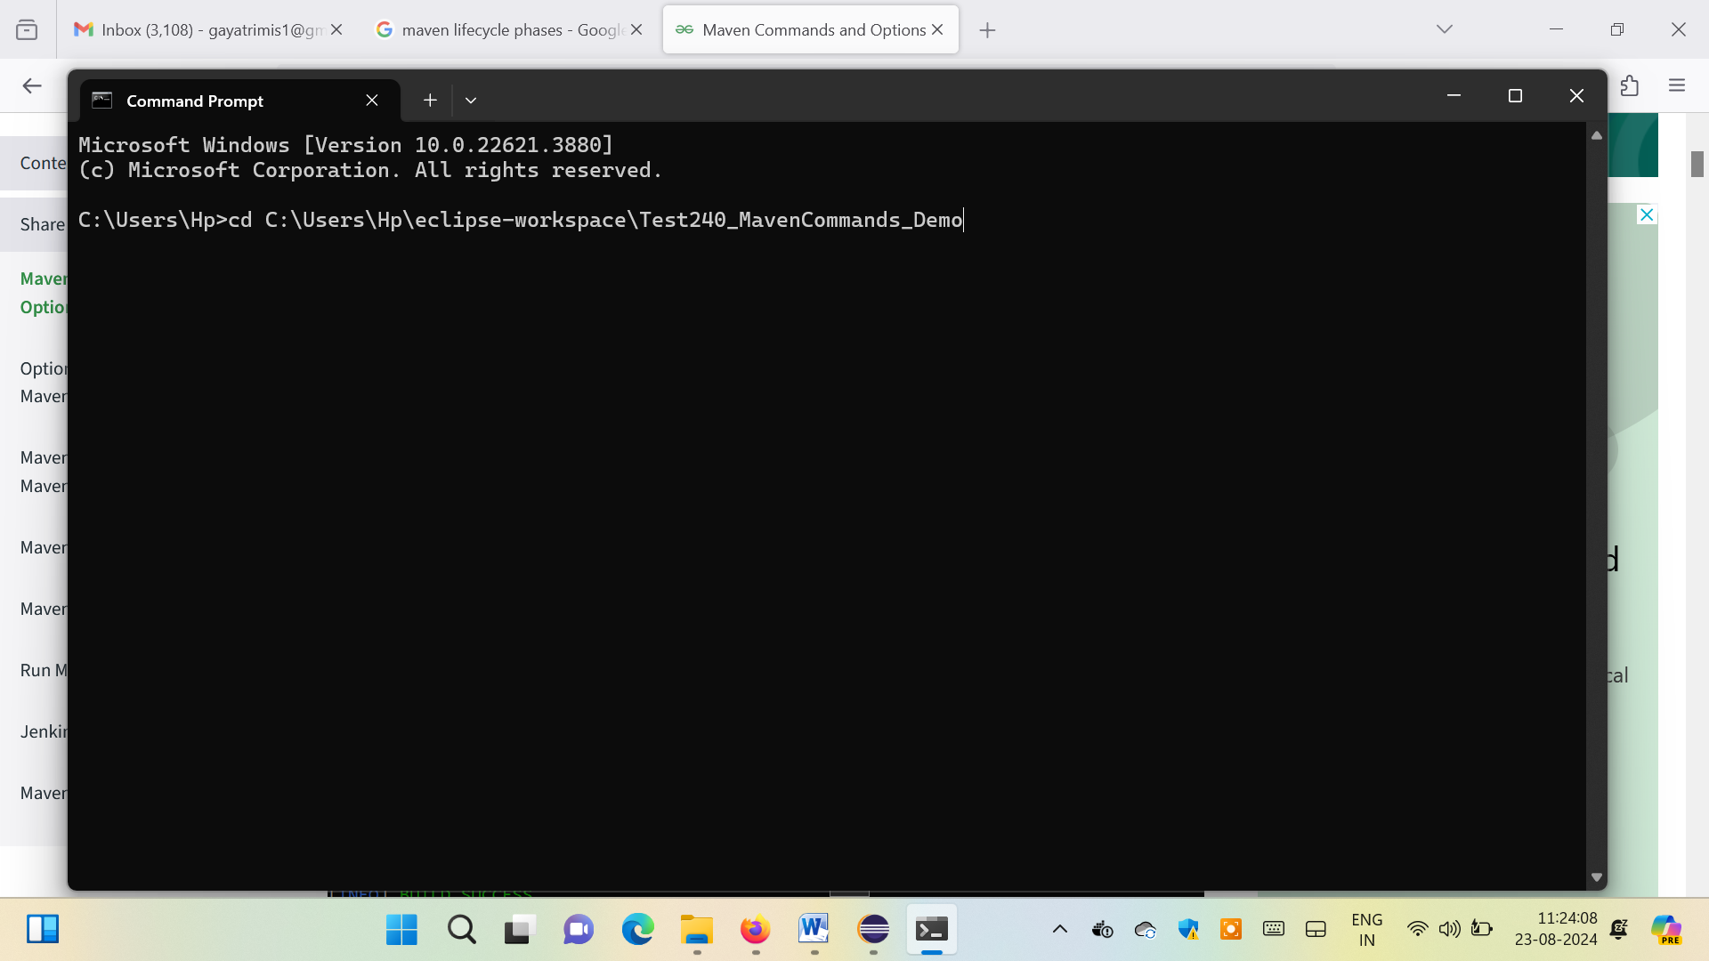

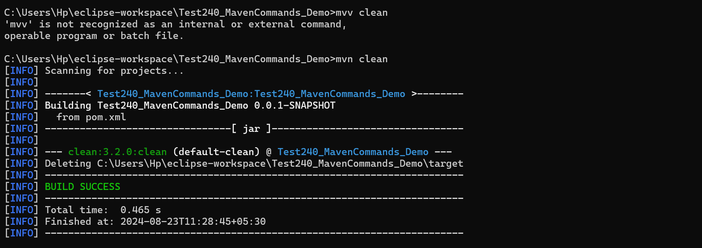

Command -2

mvn complier: compile

The **mvn compiler:compile** command in Maven is used to compile the source code of a Maven project. It is part of the Maven Compiler Plugin, which handles the task of compiling Java source files.

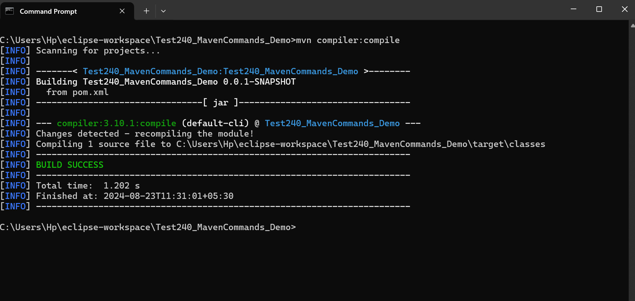

Command – 3:

mvn package

The **mvn package** command in Maven is used to compile the code, run the tests, and package the compiled code and other resources into a distributable format, such as a JAR, WAR, or EAR file. This command is a key part of the Maven build life cycle, typically used to create an artifact that can be deployed or distributed.

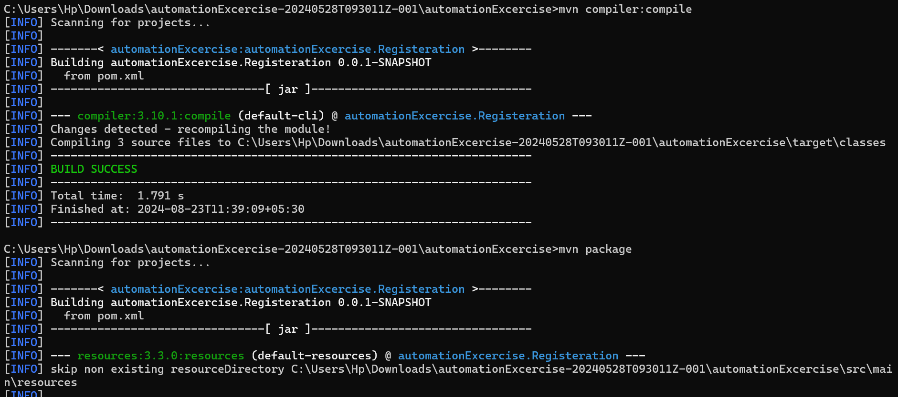

Command – 4:

mvn install

The mvn install command in Maven is used to compile the code, run tests, and package the compiled code and other resources into a JAR, WAR, or other artifact, and then install that artifact into the local Maven repository.

Command – 5:

mvn deploy

The mvn deploy command in Maven is used to compile the code, run tests, package the artifact, and then deploy the packaged artifact to a remote repository. This remote repository is typically used for sharing the artifact with other developers or systems, and it can be a private repository within an organization or a public repository like Maven Centra.

Command – 6

mvn validate

The mvn validate command in Maven is used to validate the project structure and configuration. This command checks the project for correctness before starting the build process. It ensures that all necessary information is available and correct before proceeding to subsequent phases of the build life cycle.

Command – 7

mvn dependency:tree

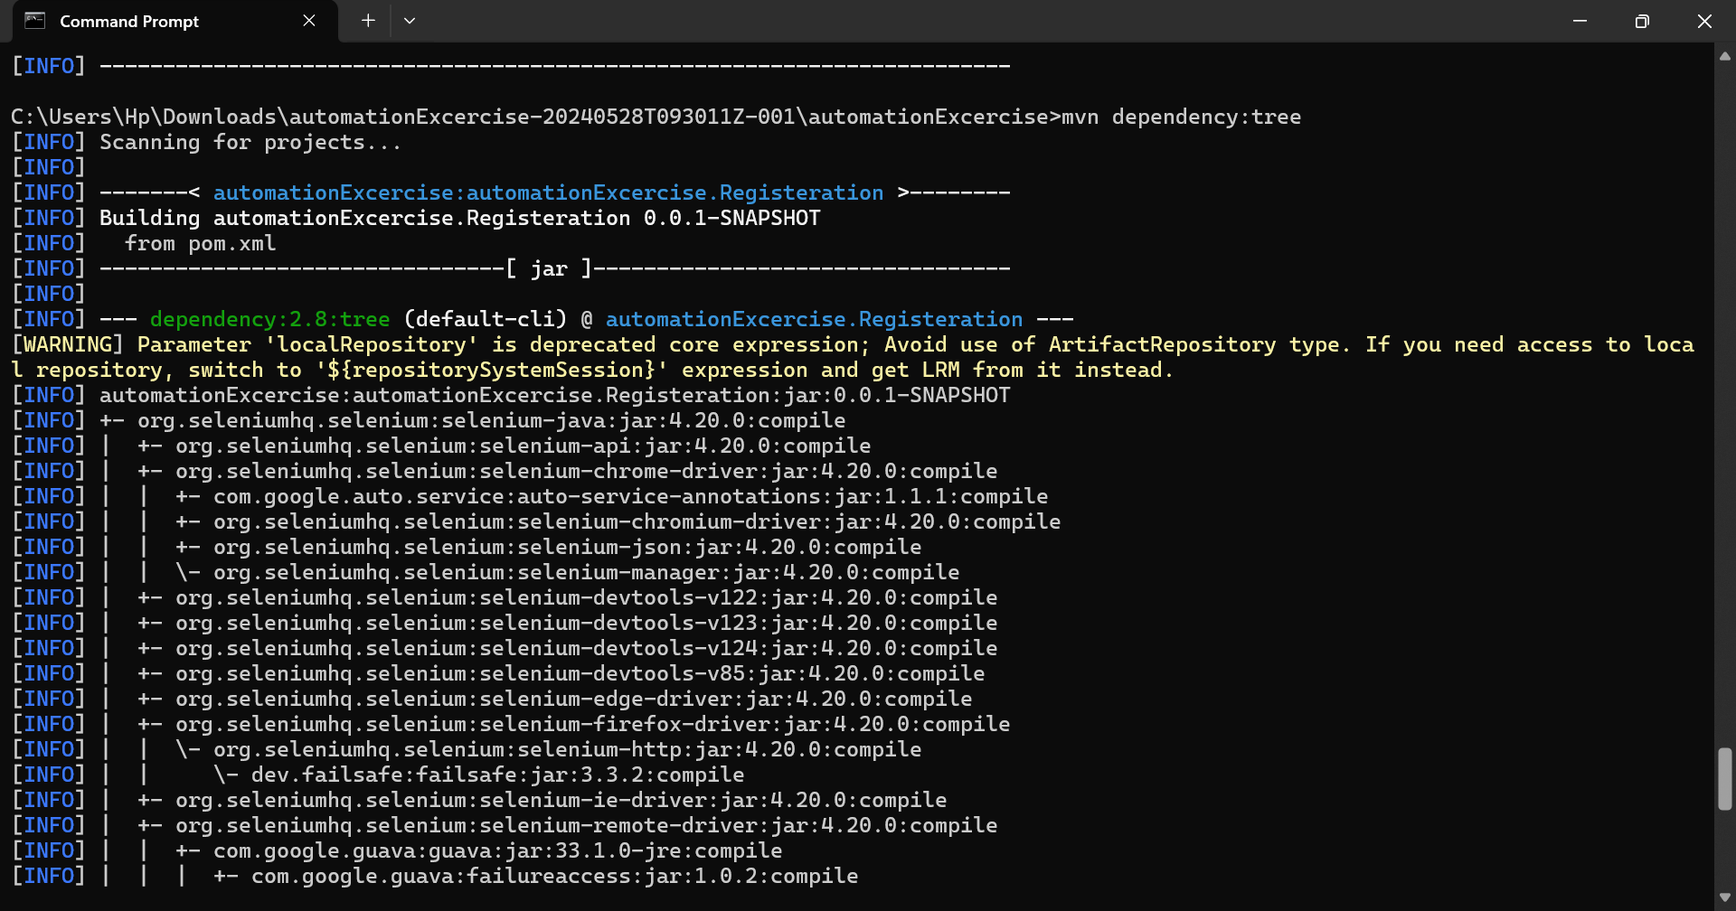

Command – 7:

mvn dependency:analyse

The **mvn dependency:analyze** command in Maven is used to analyze the dependencies of a project to identify unused declared dependencies and detect used but undeclared dependencies. This command is part of the Maven Dependency Plugin, and it helps ensure that your pom.xml file accurately reflects the actual dependencies of your project.

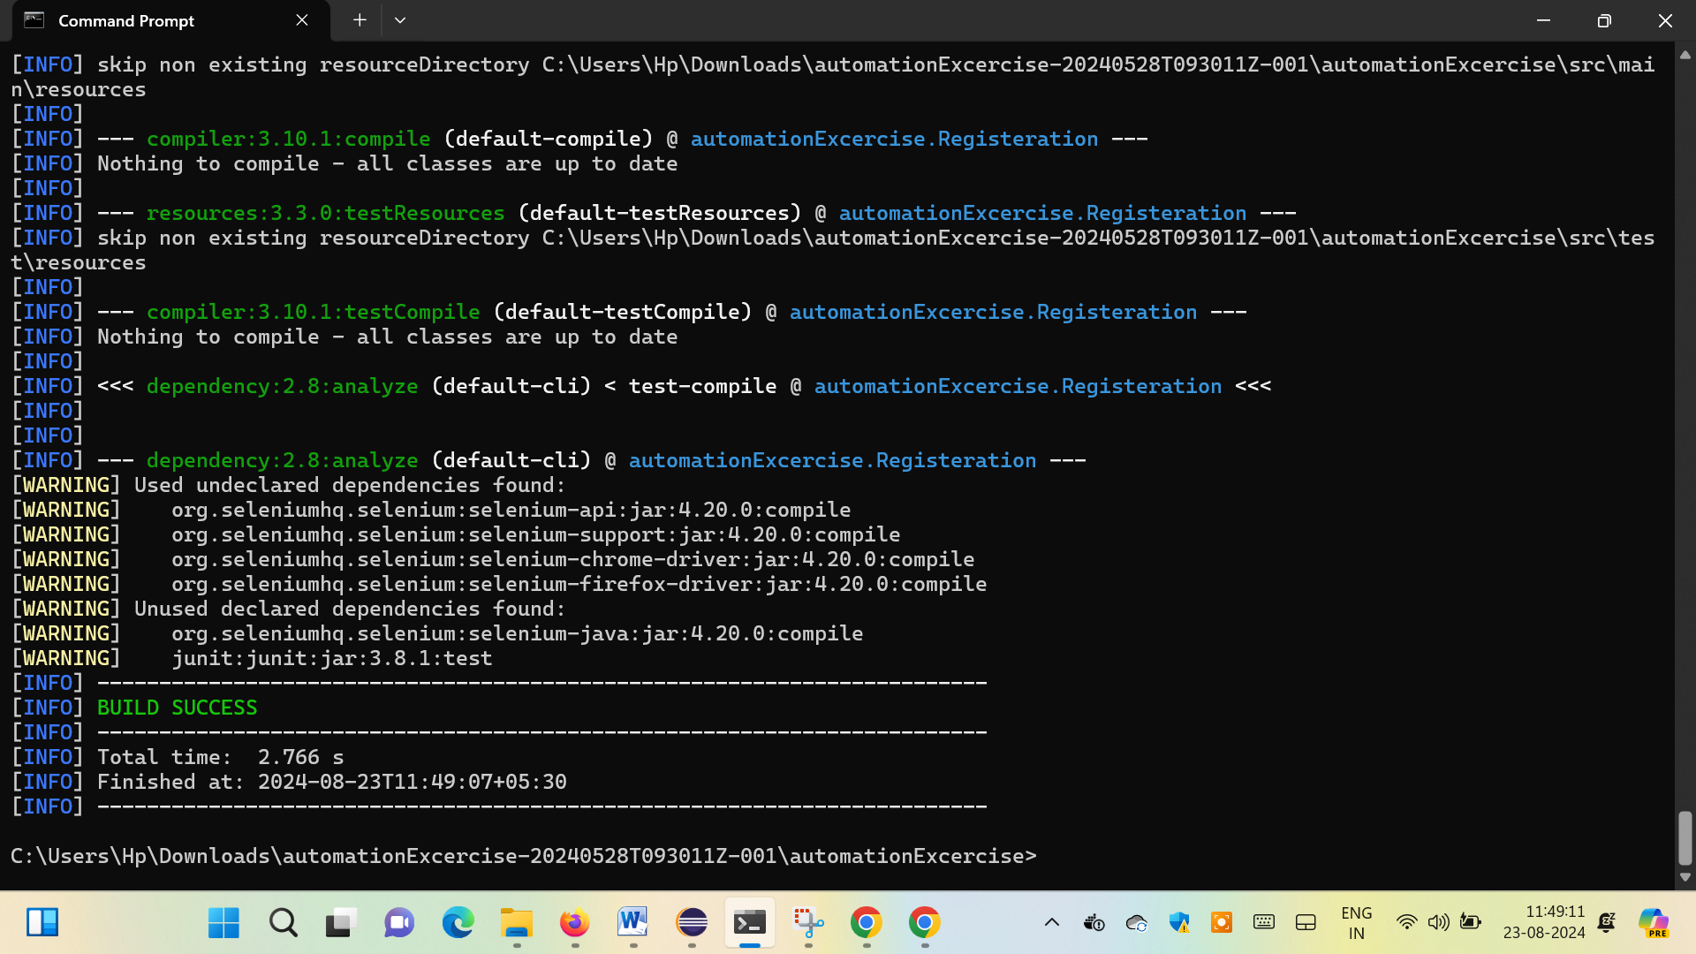

Command – 8:

mvn archetype:generate

To create a new project archetype from the existing

Command – 9:

mvn site

The **mvn site:site** command in Maven generates the project’s site documentation. This command is part of the Maven Site Plugin, which is used to generate a website or documentation for your project.

Command-10:

mvn test

The **mvn test** command in Maven is used to execute the tests in a Maven project. When you run mvn test, Maven will compile the project’s source code and then execute the test cases present in the project using a testing framework like JUnit or TestNG.